7.0.11 Editors - 3D View - Text - Edit Mode - Text context menu
Edit Mode - Text Context Menu 2
Cut 2
Copy 2
Paste 2
Select All 2
Text 2
Cut 2
Copy 2
Paste 2
Paste File 2
To Uppercase 2
To Lowercase 2
Last Operator Set Case 2
Special Characters 3
Move Cursor 3
Toggle Bold 3
Toggle Italic 3
Toggle Underline 3
Toggle Small Caps 3
Kerning 3
Decrease Kerning 3
Increase Kerning 3
Reset Kerning 4
Last Operator Change Spacing 4
Delta 4
Delete 4

Edit Mode - Text Context Menu

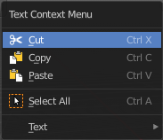
Call this menu with double right click in the 3D viewport. You need to be in Edit mode with a Text object.

Cut
Cuts the selection.

Copy
Copies the selection.

Paste
Pastes a copied selection.

Select All
Selects the whole text.

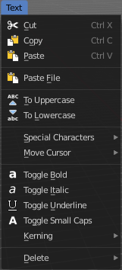
Text

Cut
Cuts the selection.

Copy
Copies the selection.

Paste
Pastes a copied selection.

Paste File
Opens the file browser where you can choose a text file to paste the text from. It needs to be UTF8.

To Uppercase
Sets the selected text to be uppercase letters.

To Lowercase
Sets the selected text to be uppercase letters.

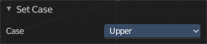
Last Operator Set Case
Set Case has one Last Operator for all items.

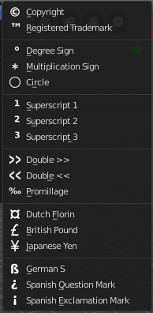
Special Characters
Special characters is a sub menu that contains some special text characters, like copyright, which you can insert into the text.

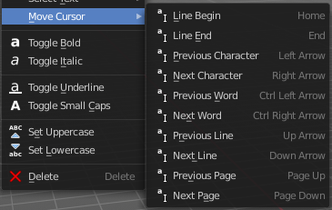
Move Cursor
Set the cursor at specific positions in the text.

Toggle Bold
Bold sets the selected letters to be displayed as bold letters.

Toggle Italic
Italic sets the selected letters to be displayed as italic letters.

Toggle Underline
Underline sets the selected letters to be displayed as underlined letters.

Toggle Small Caps
Toggle small caps sets the selected letters to be displayed as if they were upper case letters, but with lower case size.

Kerning
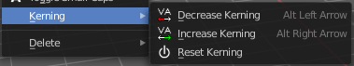
Kerning is the distance between letters. Increase, decrease and reset the kerning.

Decrease Kerning
Decreases the distance between the letters.

Increase Kerning
Increases the distance between the letters.

Reset Kerning
Resets the distance between the letters to the default values from the font.

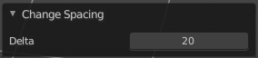
Last Operator Change Spacing

Delta
Adjust the spacing. The range goes from -20 to 20.

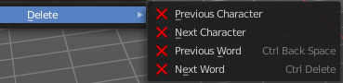
Delete
Deletes the selected text.

